**EXPLORATORY DATA ANALYSIS (EDA) REPORT ON AMES HOUSING DATASET**

**OBJECTIVE:**

The objective of this EDA is to gain insights into the Ames Housing dataset, focusing on understanding the relationships between various features and the target variable 'SalePrice.' The analysis aims to identify key patterns, correlations, and potential influential factors affecting house prices.

**DATA INSPECTION:**

The initial steps included inspecting the data to identify missing values and outliers. Certain columns ('Alley', 'Mas Vnr Type', 'Fireplace Qu', 'Pool QC', 'Fence', 'Misc Feature') were dropped from categorical variables due to a significant number of missing values. Missing values were then handled using imputation strategies such as filling with the median or most frequent value. Columns with unique identifiers ('Order', 'PID') were dropped as they did not provide meaningful information. No duplicated observations were found.

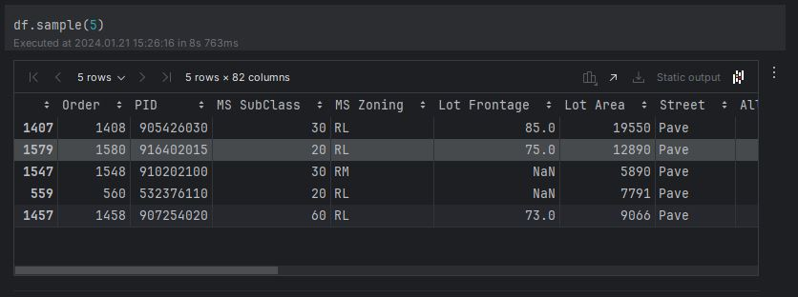

**DATA OVERVIEW:**

After successful data wrangling, the dataset comprises a total of 2930 entries, each representing a residential property, with 76 columns containing various attributes and characteristics of these properties.

Numeric Features:

* Integers (26 columns): These columns include essential numerical features such as 'MS SubClass,' 'Overall Qual,' 'Year Built,' 'Full Bath,' representing counts or discrete values.
* Floats (11 columns): Numeric columns with decimal values, encompassing 'Lot Frontage,' 'Mas Vnr Area,' 'BsmtFin SF 1,' and others.

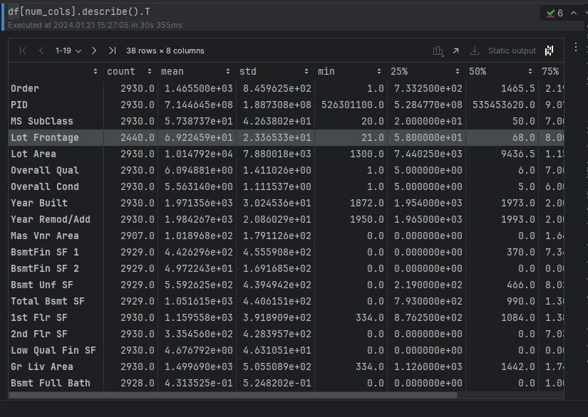

Categorical Features:

* Objects (39 columns): These columns represent categorical variables like 'MS Zoning,' 'Street,' 'Land Contour,' and 'Utilities.' They describe qualitative aspects of the properties.

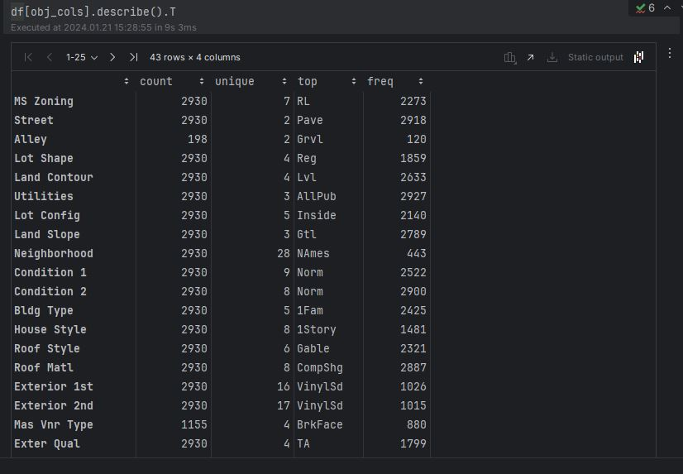

Target Variable:

* SalePrice (1 column): The 'SalePrice' column serves as the target variable, representing the sale prices of residential properties. It is of integer type.

Data Integrity:

* The dataset shows no missing values, indicating careful preprocessing to ensure completeness.
* A diverse set of data types (integers, floats, objects) enhances the richness of information available.

Data Size:

* With 2930 observations (rows) and 76 columns, the dataset is substantial, offering a wealth of information for analysis and modeling.

**Additional Insights:**

* Features Describing Physical Attributes:
* Various features provide insights into the physical characteristics of the properties, such as 'Lot Area,' 'Gr Liv Area,' 'Mas Vnr Area,' and others.
* Location and Surroundings:
* Location-related features include 'MS Zoning,' 'Neighborhood,' and 'Land Contour,' offering information about the geographic context of the properties.
* Temporal Information:
* Temporal aspects are captured through features like 'Year Built,' 'Year Remod/Add,' and 'Yr Sold,' providing information about the construction, remodeling, and sale years.
* Amenities and Infrastructure:
* Features such as 'Garage Cars,' 'Fireplaces,' 'Wood Deck SF,' and 'Pool Area' describe amenities and infrastructure associated with the properties.

**CORRELATION ANALYSIS:**

Correlation analysis was conducted to understand the relationships between numerical features and the target variable ('SalePrice'). The correlation matrix revealed significant correlations, with 'Overall Qual' demonstrating the strongest positive correlation (0.799262) followed by 'Gr Liv Area' (0.706780), 'Garage Cars' (0.647812), and 'Garage Area' (0.640381). These results provide valuable insights into the features most strongly associated with house prices.

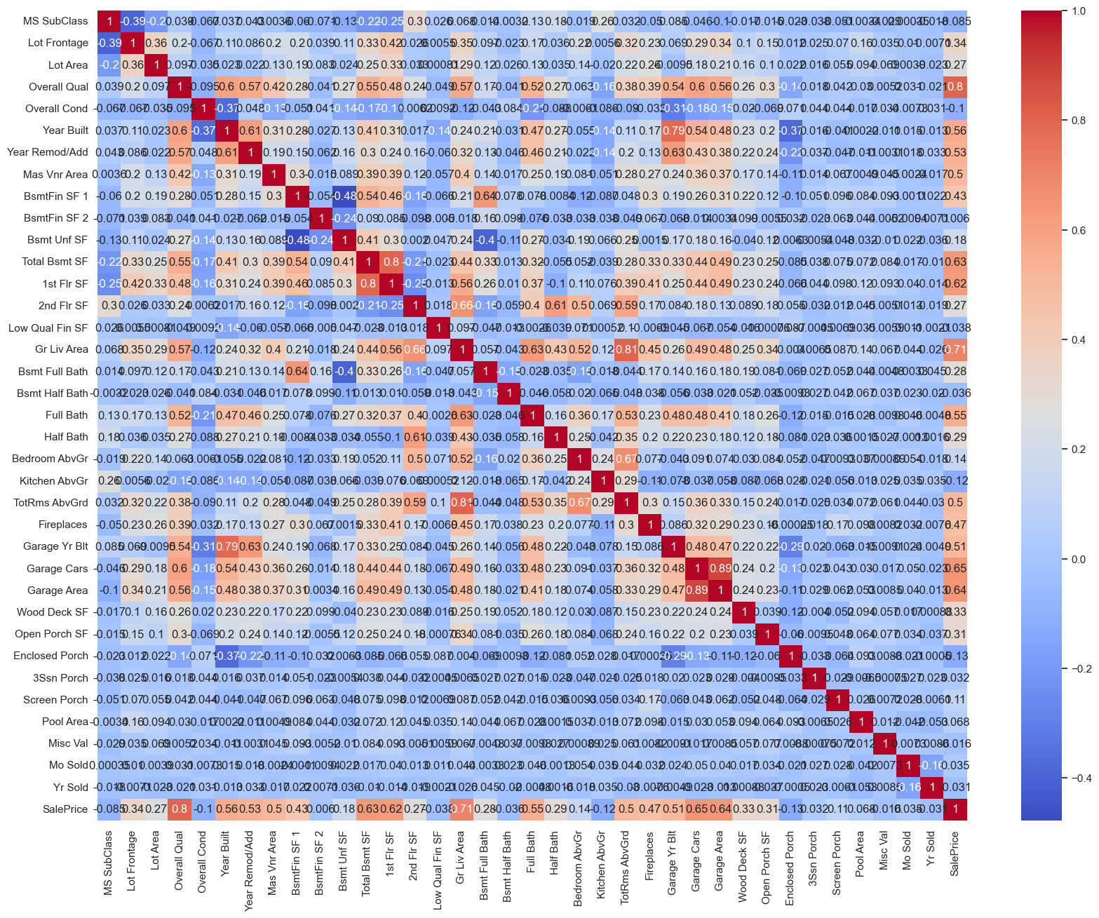

**KEY FINDINGS:**

* Overall Quality and Living Area Impact: The overall quality of a house ('Overall Qual') and the above-ground living area ('Gr Liv Area') have the most substantial positive impact on house prices. As these variables increase, the sale price tends to increase.
* Garage Characteristics: The number of cars a garage can accommodate ('Garage Cars') and the garage area ('Garage Area') also demonstrate strong positive correlations with sale prices.
* Basement and First-Floor Space: The total basement area ('Total Bsmt SF') and the first-floor area ('1st Flr SF') are additional features with strong positive correlations, indicating their impact on house prices.
* Year Built and Remodeling: The construction year ('Year Built') and the year of remodeling or addition ('Year Remod/Add') moderately positively correlate with sale prices.
* Negative Correlations: Several features exhibit negative correlations, but their impact on sale prices is relatively weaker compared to the positive correlations.

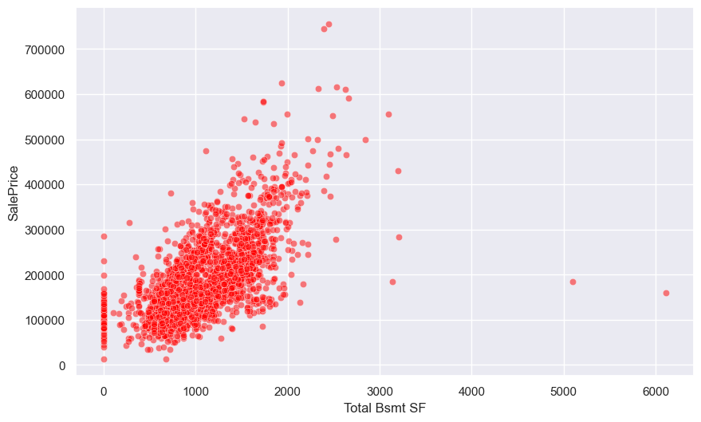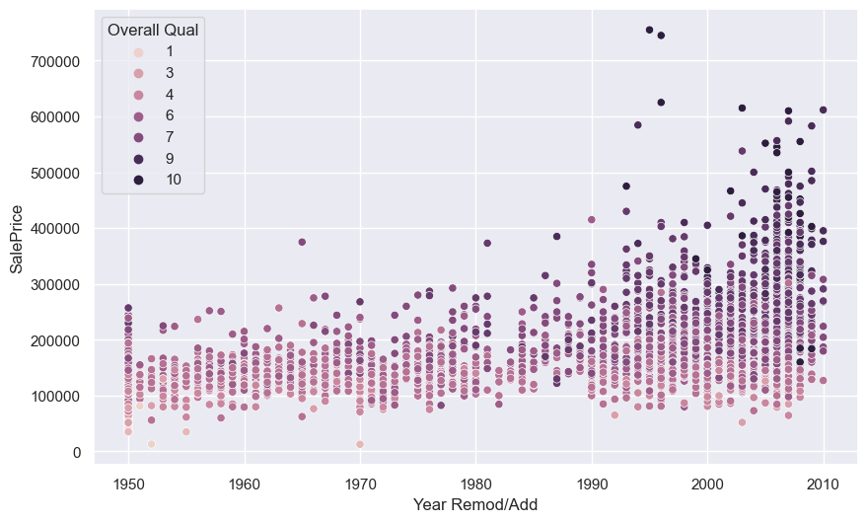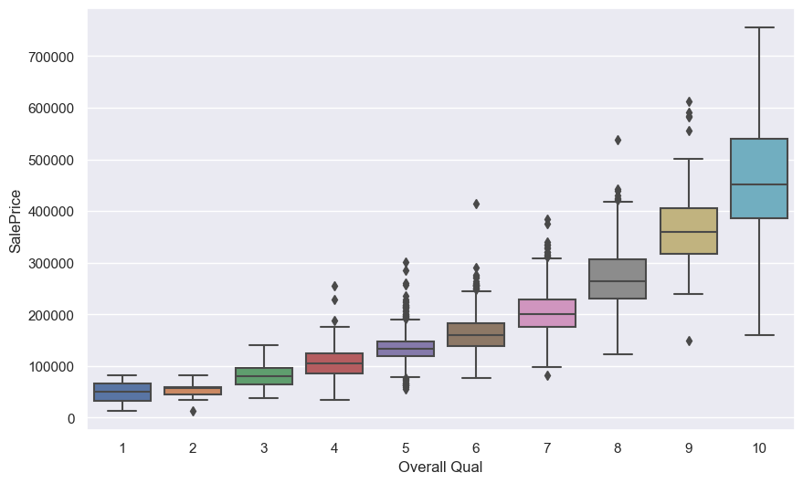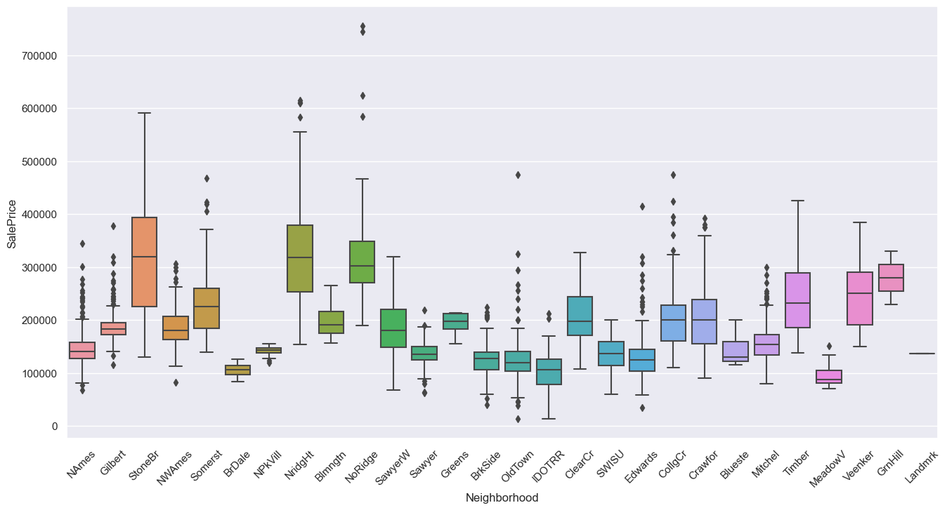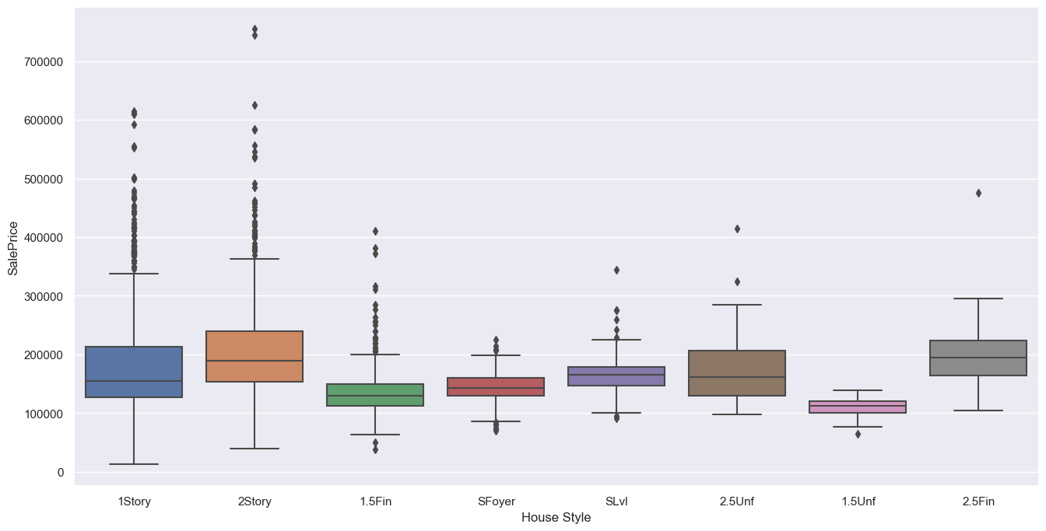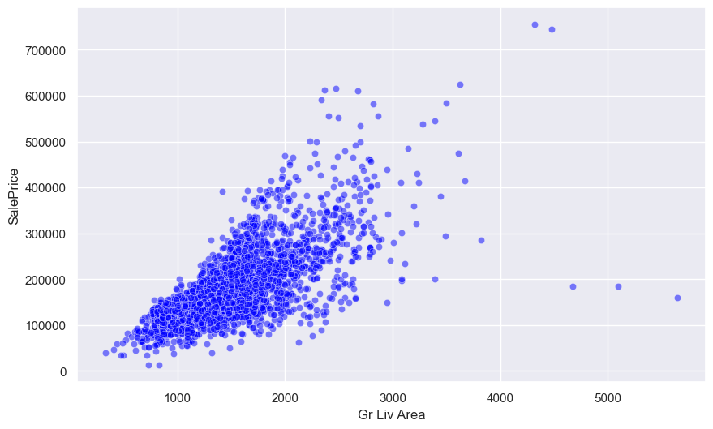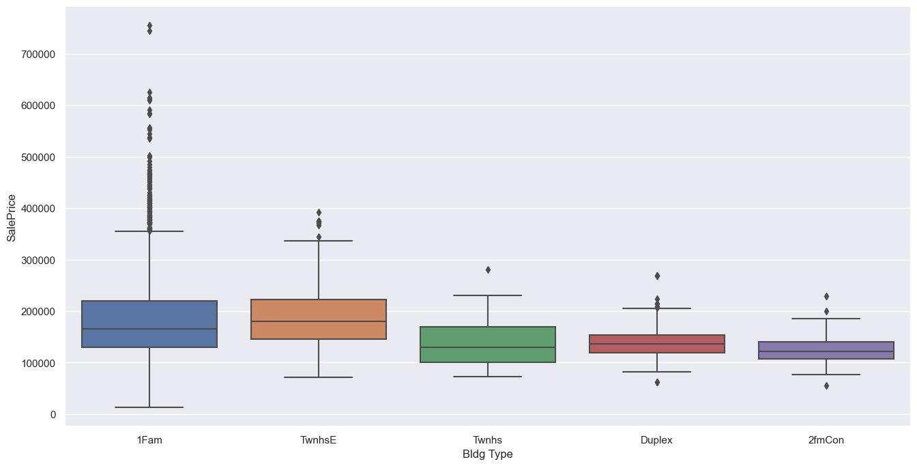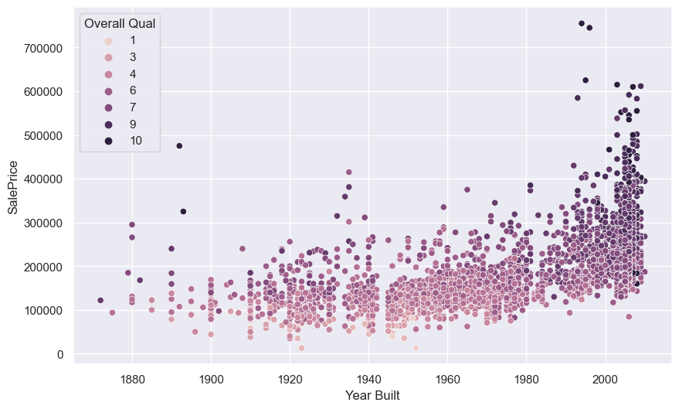

**RECOMMENDATIONS:**

* Focus on Quality and Space: Builders and sellers may consider emphasizing the overall quality of houses and maximizing living space to potentially increase sale prices.
* Garage Features: Highlighting garage features, such as capacity and area, can positively influence house prices.
* Consider Remodeling: Investing in remodeling or addition projects can contribute to increased sale prices, as suggested by the positive correlation with 'Year Remod/Add.'

**NEXT STEPS:**

* Regression Modeling: Build regression models to quantify the impact of identified features on 'SalePrice' and assess the predictive power of the model.
* Outlier Investigation: Further investigate potential outliers identified during the analysis to determine if they require special attention or removal.
* Feature Engineering: Explore additional feature engineering techniques to enhance the predictive power of the model.
* Data Preprocessing: Continue with data preprocessing steps, such as handling categorical variables, encoding, and scaling, in preparation for model training.

**CONCLUSION:**

This EDA provides valuable insights into the factors influencing house prices in the Ames Housing dataset. The identified features, especially 'Overall Qual' and 'Gr Liv Area,' play crucial roles in determining sale prices. The recommendations aim to guide stakeholders in the real estate industry to make informed decisions and optimize the value of properties. Further steps involve advanced modeling techniques to refine predictions